INS3121
December 17th, 2018

Group 6: Assoc. Prof. Pelin Özener
Group 7: Asst. Prof. Dr. Nejat N. Çetinkaya

SOIL MECHANICS
MIDTERM II
Q.1/25p | Q.2/30p | Q.3/15p | Q.4/30p | TOTAL
Name and Surname:
Number:
Group:

- a) Determine which soil given below is normally consolidated or overconsolidated clay. Which one has more convenient properties for foundation? Explain with reasons. (10p).
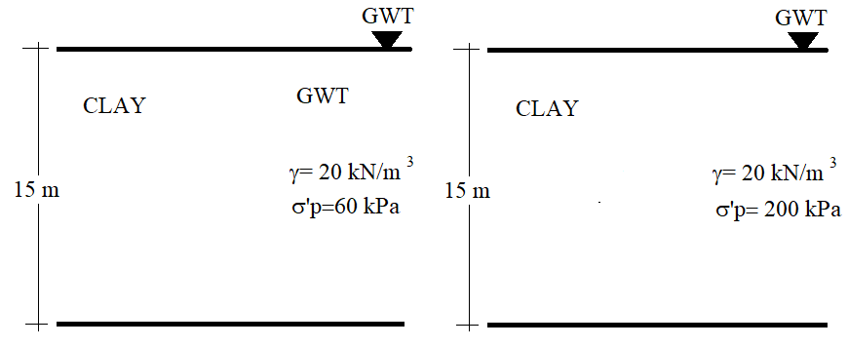
- Which laboratory tests are used to determine the shear strength parameters of soils? Briefly describe the unconfined compression test (7p).
- What are the assumptions of “Terzaghi’s Consolidation Theory”? Explain briefly (8p).

- A highway embankment of 2.5 m high is to be constructed over a soil profile shown in figure. 20 mm thick clay sample was recovered from clay soil and a consolidation test performed in the laboratory. The results of the consolidation test are given below. If the initial void ratio (e₀) of the clay sample is 0.864,
- Draw the (e) – (logσ’_{v}) curve and determine the preconsolidation pressure (σ_{p}’), compression index (C_{c}), and swelling index (C_{s}) (15p).
- What is the total settlement (δc) of the embankment? (Embankment covers a large surface in the field) (10p).
- If the consolidation coefficient of the clay soil is c_{v}= 0.04865 cm²/min, compute the settlement of the embankment after 1 year (5p).
Stress (kPa) | Void ratio (e)
50 | 0.812
100 | 0.809
200 | 0.800
400 | 0.763
800 | 0.667
1600 | 0.563
3200 | 0.455
6400 | 0.358
1600 | 0.397
400 | 0.423
50 | 0.458
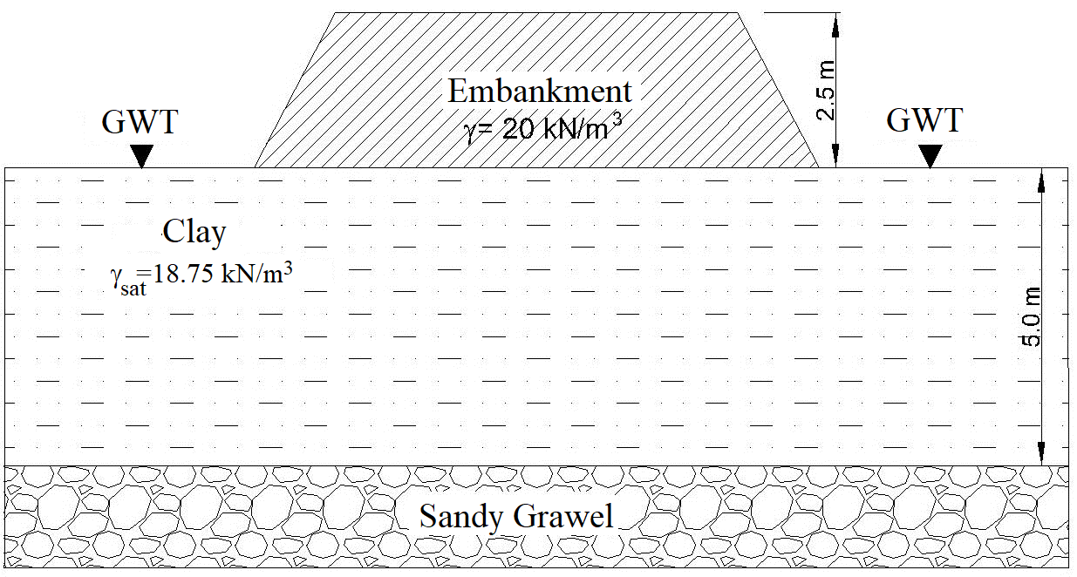
U (%) | T_{v}
10 | 0.008
20 | 0.031
30 | 0.071
40 | 0.126
50 | 0.197
60 | 0.287
70 | 0.408
80 | 0.567
90 | 0.848

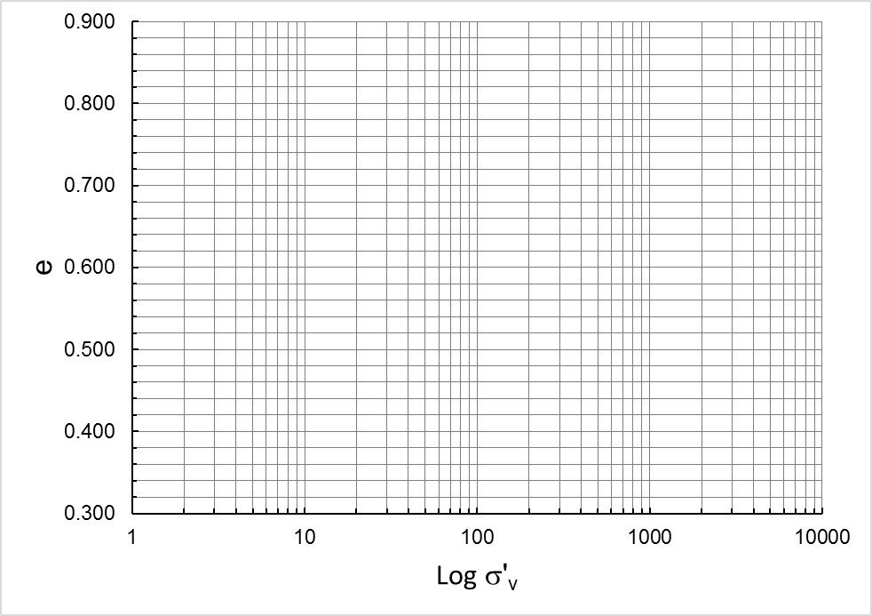

- An unconfined compression test was carried out on a saturated clay sample that has a diameter of 38 mm and a height of 76 mm. The test result obtained from the experiment is given in the below figure. Based on this result,
  - Determine the undrained shear strength (c_{u}) of the clay soil (Don’t apply area correction) (7p).
  - Plot the Mohr Circle for the unconfined compression test and show undrained shear strength value on the Mohr Circle (5p).
  - Describe the consistency of the clay soil according to the description given in the below table (3p).
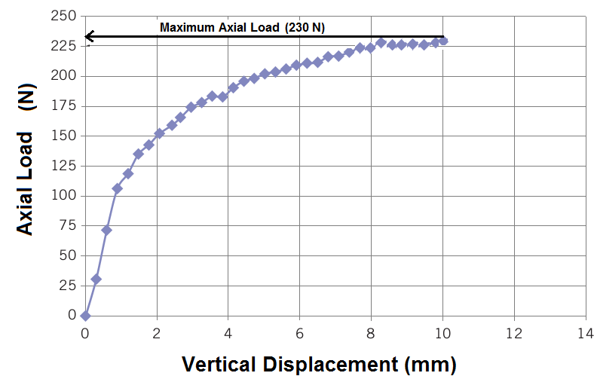
Discription | c_{u} (kPa or kN/m²)
Very Soft | <10
Soft | 10-25
Medium Stiff | 25-50
Stiff | 50-100
Very Stiff | 100-200
Extremely stiff | >200

- A series of CD triaxial tests and a UU triaxial test were carried out on undisturbed and saturated clay samples. The results of triaxial test performed clay soil samples are given in the below table. Based on this information,

- Compute the drained shear strength parameters of the clay soil from CD test (10p).
- Determine whether the soil is normally consolidated or overconsolidated clay (5p).
c) Determine undrained shear strength parameters of the soil from UU test (5p).
d) Plot the Mohr Circle and failure envelopes for the UU test and CD tests (10p).

Test type | Cell pressure (kPa) | Deviatoric Stress (kPa)
1.CD Test | 100 | 150
2.CD Test | 180 | 240
1.UU Test | 120 | 290

Time is 90 minutes. Good Luck…

